Chapter 8: Quadratic expressions and algebraic fractions

Test A answers

Part A – Multiple-choice
1 B
2 D
3 A
4 E
5 C
6 A
7 C
8 B
9 D
10 A

Part B – Short-answer
1 a 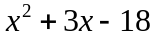 b 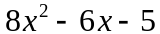 c 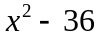
d 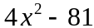 e 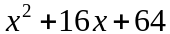 f 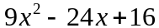
2 a 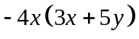 b 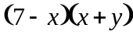 c 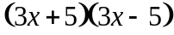
d 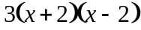
3 a 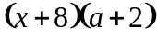 b 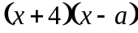
4 a 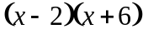 b 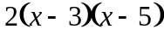 c 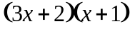
d 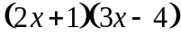
5 a 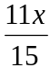 b 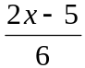 c 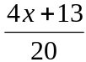
d 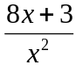 e 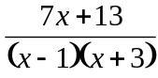 f 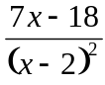
6 a b 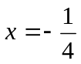

Part C – Extended-response
1 a 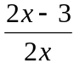 b 